REINFORCEMENT LEARNING(Q-learning)

Matlab code:

R=zeros(6,6);

R=R-1;

R([5,10,16,20,21,23,25,28,30])=0;

R([35,36])=100;

Q=zeros(6,6);

gamma=0.8;

goal=6;

state=randi([1,6]);

for i=1:1000

AS=[];

%Creating set of all possible Actions

for A=1:6;

if R(state, A)~=(-1)

AS(end+1)=A;

end

end

AS;

%Selecting Random Action

A=AS(randi(numel(AS)));

next_state=A;

Q(state, A)=R(state,A)+gamma*(max(Q(next_state,:)));

state=next_state;

end

Q=Q*100/max(Q(:))

start=3;

state=start

state1=[]

while state~=goal

[Aval, A]=max(Q(state,:));

state1(end+1)=state;

state=A;

end

state1(end+1)=state

OUTPUT:

Q =

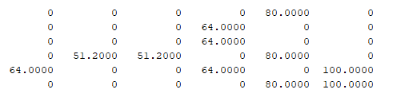

state1 = 3 4 5 6